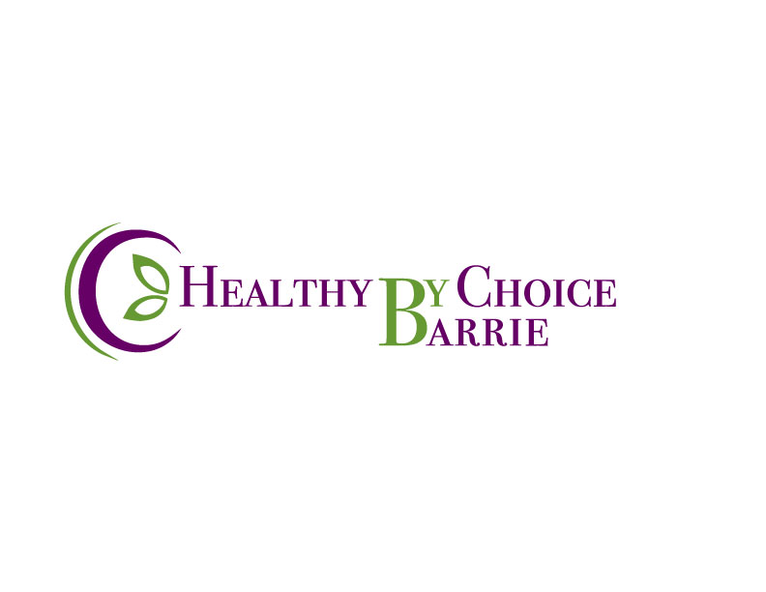
208 Bayfield St. Barrie, ON. 705-321-3077 nancy@naet.ca

Disclosure and Informed Consent

I,_____________________________________, authorize Nancy Good-Kennedy, or her designate, for “NAET” to proceed with normal procedures for NAET treatments on myself and recognize:

- That it is my responsibility to inform Nancy Good-Kennedy, or her designate, of any known allergies or reasons for suspicion of same and appreciate that any lack of such information may cause a reaction leading to complications, the most serious of which and which there is the most minimal risk, being anaphylaxis. Further, I recognize the potential for same in any event.

- That I recognize that this is not a recognized medical treatment.

- That I recognize that it is most advisable to discuss this with my medical physician prior to treatment.

- That if I am undergoing any current treatment by my physician that this treatment should be referenced to the physician prior to undertaking same.

- That this treatment is done at my request and that Nancy Good-Kennedy, or her designate, assumes no responsibility for its success or failure

- That the treatment herein releases certain energy blockages using the NAET procedure.

- That it is my responsibility to have myself rechecked sometime after clearing time and before one week.

- That these treatments are done after full consideration, discussion and with the advice of my physician (or waiving advice of such physician).

- That I waive any and all responsibility of Nancy Good-Kennedy, or her designate, for any and all repercussions, consequences, reactions or otherwise, however minimal such risk may be, of the aforementioned treatment that is done on myself.

Dated this ______day of __________________2016__.

Signature_____________________________________.

Cancellation policy

I have read and am aware of the cancellation policy at Healthy by Choice.

Signature______________________________________________________________

