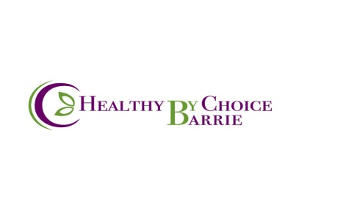
208 Bayfield St. Barrie ON. 705-321-3077 nancy@naet.ca
Explanation of N.A.E.T.
- N.A.E.T. stands for Nambudripad’s Allergy Elimination Technique and was founded by Dr. Devi Nambudripad in 1985. It makes use of acupuncture, acupressure and muscle response testing to desensitize the allergy sufferer.
- It is a non-invasive method that can be used safely on anyone. In N.A.E.T, allergies are viewed from a holistic perspective, based on Oriental Medicine principles. When contact is made with an allergen, it causes blockages in the energy pathways, called meridians. This blocked energy flow is the first step in an allergic response. I remove these blockages using acupressure and/or acupuncture.
- There are a set of basic treatments that are done first. It’s most important that your body is absorbing the nutrients so that you can build up your immune system leaving you better able to eliminate other allergies.
- Usually it is the nutrient in the food that you are allergic to and not the actual food, therefore, when I treat (desensitize) the nutrient the food allergy will usually clear, e.g. treating calcium will usually eliminate a dairy sensitivity, treating vit. C will usually eliminate a fruit and berry sensitivity, etc. (to treat something indicates the desensitization process has been completed)
- By the time the basics are completed most of the food allergies are eliminated (healthy foods). Examples of foods that do not clear in the basics are spices, artificial foods, nuts, chocolate, coffee, fats. These are foods that can be cleared once the basic nutrients are completed.
- If the basics are not done first the other allergy treatments will not hold. Dr. Devi has spent over 18 years researching this.
- If you are not allergic to one of the basics then we move on-to work on the reason why you came in, i.e. Candida, Asthma, Headaches, Environmental Illness, Pet allergies, Fibromyalgia, CFS, ADD/ADHD, etc.
- Some people can have detox reactions from the treatments, e.g. headaches, nausea, emotional, etc. which may last a few hours to a few days. This detox does not happen often but it is possible. Please let me know if this happens to you. If after 48 hours you are not feeling the same as before the treatment or better than before the treatment, you should have your treatment rechecked as you may need a combination with your treatment.
- By the time the basics are completed you should have more energy and less cravings because you will now be absorbing the nutrients from the foods you eat. e.g. If you are allergic to grains/yeast you will usually eat a lot of breads. Your body is craving it because it’s not getting the nutrients from it. Once the allergy is treated you will no longer crave or need to eat a large amount of bread, therefore, you can lose weight. If you continue to eat as much bread you can gain weight. The reverse is also true, if you are allergic to most foods and you are underweight, by eliminating the allergy to those foods you will now be able to eat and gain weight.
- While treating allergies with N.A.E.T. unmasking may occur. This means that as you’re clearing allergies other “hidden” allergies may present themselves. You may or may not have known that you had these hidden allergies but they are present and need to be removed as they are putting blockages on energy channels.
- Your initial visit is $110.00 and includes your first treatment; following visits are $70.00 including H.S.T. (please note, payment via cash, e-transfer, or cheque only as no access to debit or credit machines)
- You can do up to 3 treatments per week (no more than) or you can do whatever you have time and, of course, money for. Remember, you didn’t get this way overnight and it will take time to get well. And you have the rest of your life.
- Treatments work at least 80% of the time. If they work for you it’s for life. The allergy should never return (under rare circumstances treatments may let go if there is an acute traumatic event in your life).
- If your symptoms return or you feel like all of your treatments have “let go” please let me know a.s.a.p. Usually this means you need a combination with one of the basics and often one treatment will get you back to feeling good again. This is very rare but it does happen.
- If, for any reason, you have to stop treatments for an extended period of time, upon your return you will be able to restart where you left off. It is not necessary to start all over.
- Dr. Nambudripad has written a book “Say Good-bye to illness “on N.A.E.T. which gives many case studies and can be purchased through amazon.com. If you are considering receiving NAET it is strongly recommended that you read this.

For more information view the following websites: www.naet.ca that is my website.
Dr. Nambudripad’s website is www.naet.com, the Canadian website is www.naet-canada.com
I can be reached via text message or voice mail at 705-321-3077, email nancy@naet.ca

Thank you for your interest and I hope to be part of your journey.

Nancy Good-Kennedy

